#include <windows.h>
#include <iostream>
#include <string>

int main() {
STARTUPINFOW StartupInfo;
PROCESS_INFORMATION ProcInfo;
std::wstring CommandLine = L"notepad.exe";

ZeroMemory(&StartupInfo, sizeof(StartupInfo));
StartupInfo.cb = sizeof(StartupInfo);
ZeroMemory(&ProcInfo, sizeof(ProcInfo));

if (!CreateProcessW(NULL,
const_cast<LPWSTR>(CommandLine.c_str()),
NULL,
NULL,
FALSE,
0,
NULL,
NULL,
&StartupInfo,
&ProcInfo))
{
std::cerr << "CreateProcess failed." << std::endl;
return 1;
}

WaitForSingleObject(ProcInfo.hProcess, INFINITE);

CloseHandle(ProcInfo.hProcess);
CloseHandle(ProcInfo.hThread);

return 0;
}

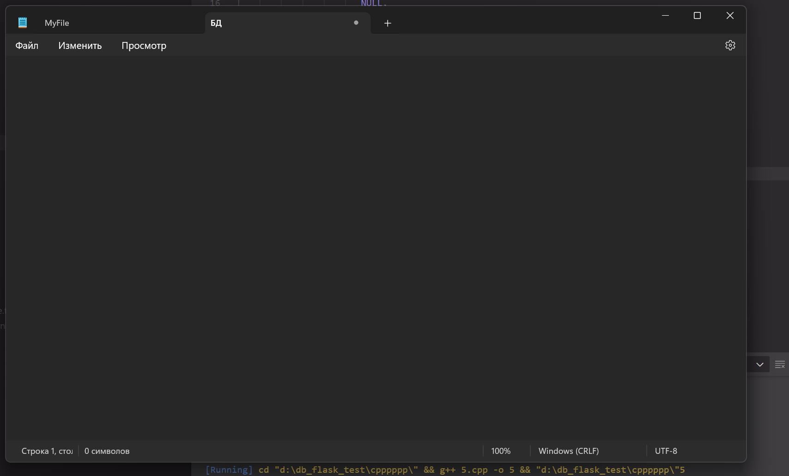

#include <windows.h>
#include <iostream>
#include <cmath>

int main() {
int N = 50000000;
double a, b;

getchar();
std::cout << "Before loop" << std::endl;

for (int i = 0; i < N; i++) {
b = static_cast<double>(i) / static_cast<double>(N);
a = sin(b);
}

std::cout << "After loop" << std::endl;
getchar();

return 0;
}

